Short text MAP EXPO:
Title: Medicinal Aromatic Plant Expo 2017 – the Global marketplace for MAP supply chain
The Global Marketplace for Medicinal & Aromatic Plants – MAP EXPO, is the commercial event which is dedicated to trade & development of MAP supply chain. MAP EXPO enhances international exports of the raw MAPs, extraction to MAP-based, herbal medicines, as well as high tech solutions for MAP cultivation & processing. The event will take place in Eindhoven, the Netherlands - the heart of top 5 EU logistics hubs, on 29 – 30 March 2017, 10:00 – 17:00. Click for more information.

Long text MAP EXPO:
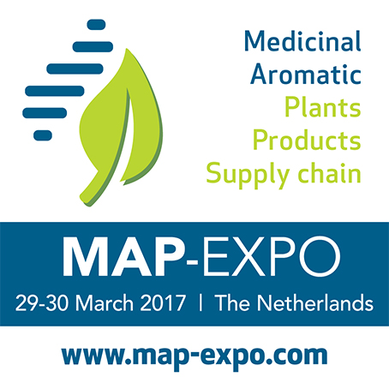
Medicinal Aromatic Plant Expo 2017 – the Global marketplace for MAP supply chain
Date: 29 – 30 March 2017
Time: 10:00 – 17:00
Venue: Eindhoven city center, the Netherlands
Audience: Professional visitors, trade & business visitors
Website: http://map-expo.com/
Email: info@map-expo.com
Fair location: Beursgebouw Eindhoven
Lardinoisstraat 8
Eindhoven, The Netherlands
http://www.beursgebouw.nl/
Participation fee for exhibitor: 150 – 200 EURO per sqm

The annual event MAP EXPO exhibits companies in early links of Medicinal Aromatic Plants' supply chain to serve the consumption industries: medicinal, pharmaceutical, beauty-care, spa, fragrance industries.

MAP EXPO covers from the commodity products such as:
- Raw Medicinal & Aromatic Plants, Algae, sea weeds, Essential Oils, Resins, Powder Herbal Materials Gels etc.

- To semi-final & private label products:
Cuisine Ingredients | Teas | Plant-Based Drugs | Plant-based Cosmetics
- And also Input - Supporting industries:
MAP Materials | Machinery, (bio) fertilizers, devices for MAP cultivation, harvesting, packaging | Innovations, solutions, certifications, standards for MAP collection or cultivation | Extraction solutions of active ingredients, phyto-chemicals, organic chemicals from MAPs | Conversion, preservation solution of MAP into MAP Products | New MAP applications for modern lives such as massage, sauna therapy, phyto-therapy, phyto-pharmaceuticals | Innovations & Solutions to maintain MAP sustainability
The MAP EXPO organizer targets the visitors who are business people, purchase managers, purchase staff, decision makers, business development managers, and entrepreneurs in Europe, USA, UK, Asian countries with purchase power such as Hong Kong, Singapore, Japan.
Benefits for exhibitors:
- Firstly the tailor-made visitor groups for your products.
- Strategic location (Eindhoven, the Netherlands) for both EU and USA, UK, exhibition hall is 3 minutes walking away from Eindhoven city stations, easily to attract visitors from foreign country.
- Seminar before the event for exhibitors about effective sales during exhibition
- MAP EXPO 2017 is only event dedicated for the supply chain of MAP, for all conventional, natural, and bio products.
- On-floor advertisement across supply chain of MAP
- Networking reception only for exhibitors to enhance businesses across the supply chain
- Extra match-making programs for the visitors who are certified with buying requests. Thank to our network of around 30 countries, both embassies and independent organizations, we are sending our invitations to the target sectors and arrange the meetings.

